|  |  |
| --- | --- |
| [QA6T-34] [Adding Users to Deck Permissions Errors](https://dmutah.atlassian.net/browse/QA6T-34) Created: 19/Jul/18  Updated: 19/Jul/18 | |
| **Status:** | Open |
| **Project:** | [QA6 Tansey](https://dmutah.atlassian.net/secure/BrowseProject.jspa?id=10121) |
| **Component/s:** | None |
| **Affects Version/s:** | None |
| **Fix Version/s:** | None |

|  |  |  |  |
| --- | --- | --- | --- |
| **Type:** | Bug | **Priority:** | Medium |
| **Reporter:** | [Tansey Sussex](https://dmutah.atlassian.net/secure/ViewProfile.jspa?name=tsussex) | **Assignee:** | Unassigned |
| **Resolution:** | Unresolved | **Votes:** | 0 |
| **Labels:** | None | | |
| **Remaining Estimate:** | Not Specified | | |
| **Time Spent:** | Not Specified | | |
| **Original Estimate:** | Not Specified | | |

|  |  |
| --- | --- |
| **Attachments:** | Add user to full control error.JPG     Add user to modify cards error.JPG     Add user to study cards error.JPG |
| **Steps to Reproduce:** | 1. Select a deck and click edit 2. Add email address to Full Control box, click plus button, observe error (photo attached) 3. Add email address to Modify Cards box, click plus button, observe error (photo attached) 4. Add email address to Study Cards box, click plus button, observe error (photo attached) |
| **Expected Result:** | User can add other users to have full control, modify, or study a deck. |
| **Actual Result:** | Error messages prevent user from adding other users to their deck. |
| **Epic Link:** | [Cards Testing](https://dmutah.atlassian.net/browse/PROJ-18) |

|  |  |
| --- | --- |
| **Description** |  |

|  |
| --- |
| * User cannot add additional email addresses for full control, modify cards, or study cards options. * Refer to test case [QA6T-25](https://dmutah.atlassian.net/browse/QA6T-25) Open |

Generated at Wed Aug 08 23:18:22 UTC 2018 by Tansey Sussex using Jira 1001.0.0-SNAPSHOT#100090-sha1:e1f36159049942a868292ec329caab3852405e7e.

Add User to Full Control

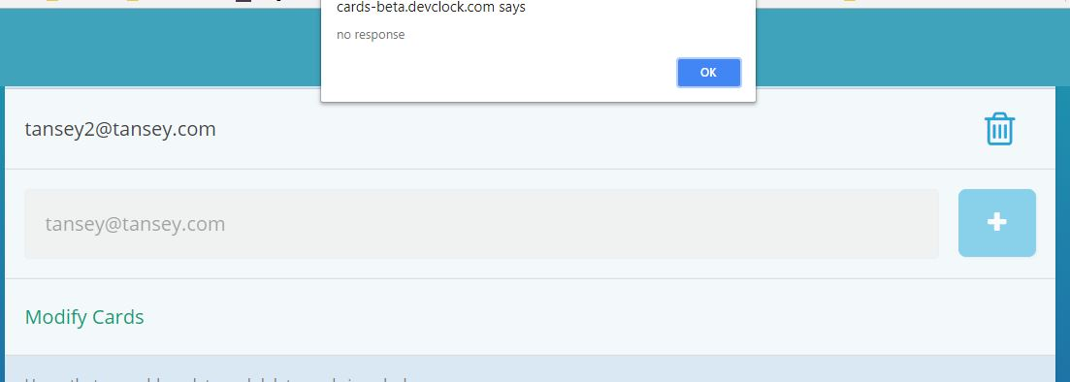

Add User to Modify Cards

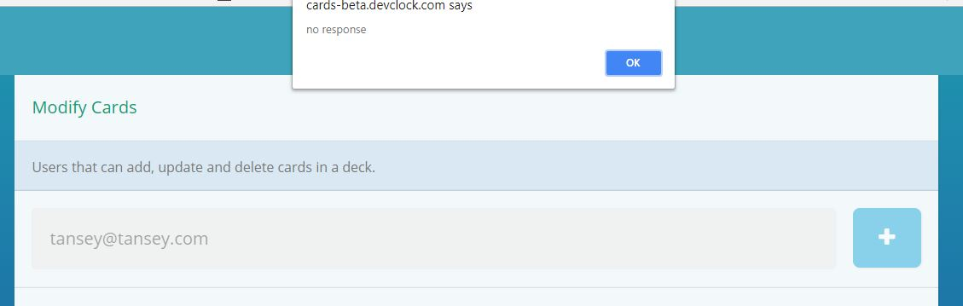

Add User to Study Cards

